FIELD SHCOOL REPORT GHANA 2011
Submitted by
Jo’Anne Yearley RN, MN, PNC(C)
Faculty Health & Human Services

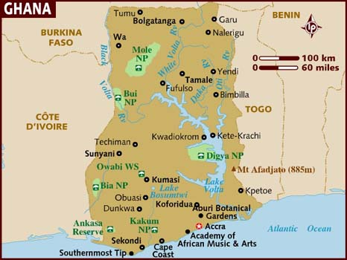

BACKGROUND
Vancouver Island University (VIU) and the Bachelor of Science in Nursing (BSN) Program in particular has a history of international field schools. In the past BSN students have traveled to Thailand, Dominican Republic and Nepal with the goal of interacting and learning with health care partners working on the ground in the host country. Global health practices and initiatives link closely with the third year BSN curriculum. Students teaching and learning goals for their practice courses reflect theory course content as well as previous courses in community nursing and community development.
Previous Ghana field schools have included faculty and students from a number of VIU programs for example: Tourism and Recreation, Forestry, Aquaculture, Social Work and Bachelor of Science in Nursing. In 2010, Maggie Kennedy, BSN faculty member, participated in a multi-program field school that included one BSN student. The 2011 Ghana field school included 2 BSN faculty members, 13 3rd year BSN students and me as support faculty member.
WHY I TRAVELED TO GHANA
Although I have traveled extensively I had not participated in a field school or in a professional capacity during my travels. I was fortunate to be awarded a VIU Travel Grant to enable me to travel to Ghana and participate in 2 field schools. I am interested in learning how a field school is run “on the ground”, how the faculty and students manage challenges related to living and working in a developing country. Exploring how faculty can continue to build local relationships with Ghanaian partners and understanding how to facilitate new relationships that would benefit Ghanaian partners and VIU were included in my personal learning plan.
I believe that travel should be a way for me to understand on a personal and professional level the phenomenological experience of living and working in another country. I had not visited Africa in my previous travels and welcomed the opportunity to visit West Africa as a representative of VIU.
I was fortunate to participate in 2 distinct field schools during my 5 week stay in Ghana. One was led by an experienced faculty member who had visited Ghana with students on 4 occasions. This field school consisted of 6 students in the Tourism and Recreation program. The field school was well organised and included research opportunities for students as well as community assessment and development projects.
The second field school focused on health and health promotion activities. The nursing team, as mentioned previously, consisted of 2 faculty members and 13 BSN students. The students had been preparing for the field school during the spring semester with fund raising events, reading circles, preparing teaching and learning projects for Ghanaian partners and studying program planning and community development theories.
My role during the first 2 weeks of my stay was to meet with Ghanaian community health partners and pave the way for the student learning opportunities. I also ensured that the travel and living arrangements for the BSN team were in place prior to their arrival. My overarching goal was to learn as much as possible about how to lead a field school, understand the local customs and protocols, and discuss partnering opportunities with hospital and nursing school partners in Sunyani, Ghana.
ACTIVITIES
May 2- 15, 2011
I attended the Brong Ahafo Research and Extension Centre (BAREC) briefing with the Tourism and Recreation Field School team and used the opportunities to ask many questions of the faculty leader, Dr. Aggie Weighill. She was very generous and gracious when sharing her Ghana experiences and was a positive role model for me as I met with various community and health care leaders. Learning how to travel by taxi in Sunyani, while seemingly a simple task in Canada, was a example of Ghanaian culture. I should note that travel in Sunyani was mainly by taxi which is inexpensive but can take additional time and energy in a hot climate. I was able to learn how to travel safely in Sunyani, how and where to purchase food supplies, who were my most valuable local contacts within BAREC and finally how to use the local Twi language to introduce myself which was much appreciated by the Ghanaians I met during my travels.
The BAREC partners were invaluable supports and guides as I navigated the local Ghanaian customs and protocols. During my stay I was the only member of the VIU teams staying in Sunyani for 3 days. Members of the BAREC team contacted me to make sure I was comfortable and safe. The 3 days provided many valuable learning experiences. I visited a local church and found myself the only Obruni (white in the Twi language) in worshiping that day. I received smiles of welcome, curious glances from some and many handshakes of welcome during the service. I met one of the parishioners the next day at her daughters fruit stand. She called me by my Ghanaian name and made sure I had the freshest fruit in my basket.
The BAREC team and I were able to make visits to a number of local contacts and followed up in writing to confirm our discussions and any arrangements that had been agreed to. Although our BAREC partner had initiated contact with the partners through e-mail or phone prior to my arrival, he did not always receive a response. We had the most productive meetings when we simply arrived at the person’s office without an appointment for an impromptu visit.
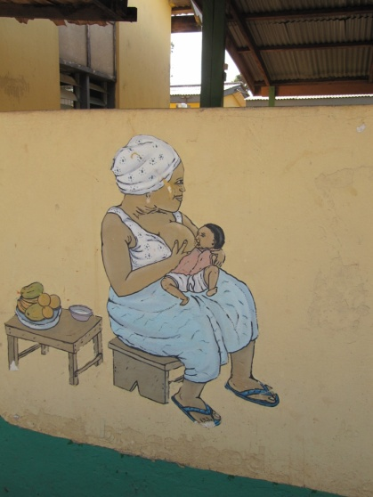 Client education at the Sunyani Municipal Hospital

May 16-19, 1011
Team members travelled to Accra, Ghana to welcome the BSN team and facilitate their introduction to Ghanaian culture. Three BAREC members accompanied the VIU team and acted as cultural interrupters for the nursing team. The BSN team visited a number of cultural sites in Accra including the Accra Art’s Centre, Kwame Nkrumah Memorial Park, and the Artisan’s Market.
While in Accra the team visited the Canadian High Commission and met with the High Commissioner, Canadian International Development Agency (CIDA) representatives and other Canadian High Commission staff. The focus of our visit was to review the VIU/BAREC projects with the High Commissioner and discuss the three main foci for Canadian aid in Africa. The priority themes are:
- Increasing food security
- Securing the future of children and youth
- Stimulating sustainable economic growth
May 20, 2011
BAREC and the BSN team hosted a Stakeholder Open House event to introduce local community partners to the BSN team. The event was well attended by our Ghanaian partners. Each VIU participant was asked to stand and introduce themselves and share one Ghanaian experiences. There was much laughter as the Canadians shared their Ghanaian experiences with the group. The BSN instructors were able to follow up on pre-arranged student activities during this event. While the Ghanaian protocol may be more structured than Canadian processes at a similar event, this open house proved to be a useful way to introduce the team to Ghanaian cultural norms when meeting important members of the community.
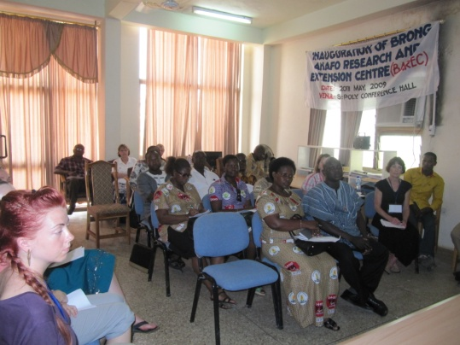
Stakeholder Open House at the BAREC office
May 21, 2011
The BSN team and BAREC cultural interpreters visited the Korkers Children’s Village to participate in teaching and learning events. While some activities did not go as planned there were rich learning experiences for students and instructors. Small children washing their hands with so much enthusiasm with the BSN students were highlights of this visit. While gift giving was challenging in that some of the children became very excited and the little ones were often left out of the process. The team gained valuable insights related to the ethics and process around gift giving in Ghana.
May 23, 2011
The BSN team visited the Regional Hospital in Sunyani, where the team met with the Deputy Director of Nursing, toured the hospital and the HIV/AIDS voluntary testing centre. The Nurses Training College visit was a highlight as we were able to participate in a lecture with Ghanaian nursing students and tour the training college facility. The lecture was on post partum care with over 80 students in the class, each one standing to ask questions of the tutor. The lack of resources was apparent as there was one white board and no other teaching resources available. At VIU we are used to computers and projectors in each classroom, along with white and chalk boards, flip charts, and markers, not to mention all the on-line library resources. This one tutor captured the attention of her class and engaged them in their learning with humour and her enthusiasm for her subject.
The team traveled to Taneso just outside Sunyani to visit the Community Health Nursing School. We met with the teaching team and finalised our arrangements for partner teaching and learning for the VIU and Ghanaian students.
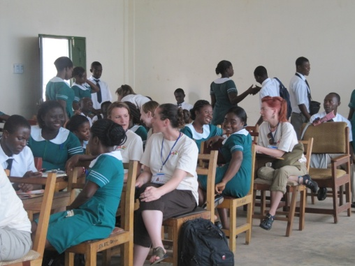
Sunyani Nurses Training College
We also visited the Hanukkah Children’s Village, a small orphanage on the outskirts of Sunyani. The student and faculty were welcomed by the team and the children. Many of us had children wanting to be carried and cuddled as we toured the facility. The facility accepts and cares for children with physical and emotional challenges who may not receive care in their home communities. Mariëtte Asagbo, who with her husband Moses, runs the facility, have been able to successfully reunite children with their families and ensure that the children are able to go to school. They have strong connections with the Sunyani Social Services programs and are well respected in the community.
During our visit we were told a new child would be coming to live at Hanukkah. A baby girl had been born in the bush and her mother had abandoned her to the elements. A hunter found the baby and brought her to the hospital. She was almost ready for discharge and will live at Hanukkah until an adoptive family is found. Her name is Selma.
I found myself reflecting what societal and economic factors had driven the baby’s mother to give birth on her own in the bush and then walk away from her child. Our Ghanaian partners had already demonstrated through their client teaching the birth control is a high priority for public health nursing teams. The teaching emphasis is on helping mothers understand that by having fewer pregnancies and births they will have more strength to care for their families. Two major causes of maternal morbidly and mortality, according to the Sunyani practice partners and my own research, are Pregnancy Induced Hypertension and Post Partum Haemorrhage. I would like to explore the potential opportunities to partner with the 2 Nursing Schools in Sunyani regarding developing teaching and learning programs, strategies and resources to address these health care challenges and provide women with alternatives to support themselves and their families.
May 24, 2011
I travelled to Goasu, 90 minutes travel outside Sunyani, to visit the Midwifery Training School. This is a new education program currently in its first year of operation. I was invited to address the students during my visit and welcomed the opportunity to reflect on the similarities of our programs for example the shared focus on Family Centred Maternity Care in both the Midwifery Training School and the VIU BSN program. The building was new and well appointed with both a library and teaching laboratory.
During my visit to Goasu I met with the local hospital administrative team, toured the maternal child, outpatient and pharmacy areas. We also visited with the local CEO and his team to discuss the need for comprehensive maternal child care in rural areas of Ghana. The Midwifery School project was significant for the town infrastructure and the CEO emphasised the importance of shared learning opportunities between the school and VIU.
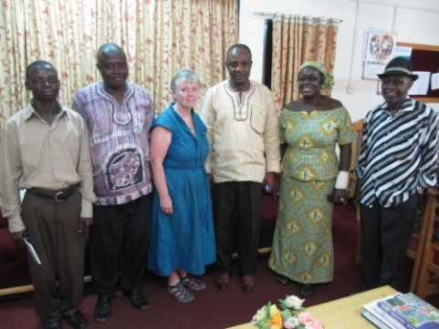
Goasu CEO& Team, Mdm. Ahmed Director Midwifery Training School
May 25-28, 2011
Travel to Mole National Park and visits to Larabanga provided an opportunity to experience a more traditional tourism experience at the park with a tour of an impoverished Ghanaian village. The Larabanga visit was facilitated by Dr. Weighill and her Larabanga contacts. Her “behind the scenes” work made this visit possible. We were able to visit the town and learn how the residents live, work, and go to school. A highlight for me was the cultural experience where a group of young girls attending a free evening school demonstrated Ghanaian dances for the group and then had our students and faculty members join in for a dance celebration.
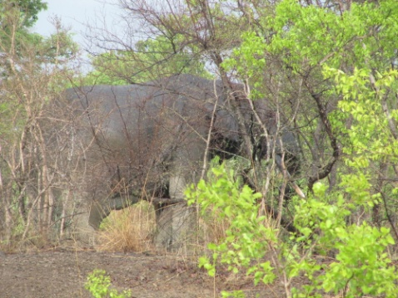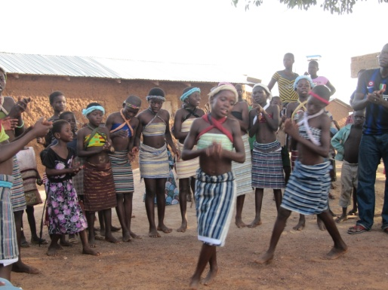
Mole Elephants Larabanga Dancers
May 29, 2011
Community Health visits with the students from the Community Health Nursing College. I was privileged to join a Ghanaian and VIU student as we visited and worked with residents in a small village just outside Tanoso. We participated in new baby assessments, elder care, teaching and learning for new mothers, and antenatal assessments. My nursing practice is based on the principle of client centred care, it was interesting for me to see how the Community Nursing College student was treated as a person of rank and stature during the home visits. A bench was brought out and then cleaned before she sat and the women and children sat on the ground or small walls. Understanding and respecting the importance of “protocol” within Ghanaian nursing practice was an important learning moment to take forward.
May 31-June 2, 2011
Travel to Cape Coast with the Tourism and Recreation Management Field School. This was an opportunity to re-enter a more Western living experience after almost 5 weeks in Ghana. We visited the Cape Coast Castle, a historic site related to the slave trade. At the end of the tour one of the Ghanaian tour participants led us in singing Amazing Grace. This hymn was written by a captain of a slave ship after he survived the sinking of his ship. The sounds of song echoed through the stone room and brought home to us all the painful history of this castle.
THE WAY FORWARD
- Practice experiences for students did not include any hands on client care due to VIU policies related to insurance coverage. I would recommend we visit the option of VIU BSN students partnering with experienced Ghanaian nurses and students and work with them in their practice. The students would have a rich practice experience and the opportunity to have shared learning with our Ghanaian partners would be strengthened.
- Increase the field school to 5 weeks. Four weeks would be spent in practice (Monday to Thursday 6 hour days), Friday for reflective meetings and the weekend free for students. One week will focus on orienting students to Ghanaian culture through visits in Accra, Mole, Larabanga and Cape Coast.
- Continue to utilise the BAREC infrastructure to support field schools. The value of having an on the ground team is crucial to the success of the field school.
- Consider sending one faculty to Ghana ahead of the main field school to ensure the arrangements are complete and finalise any outstanding issues with practice partners.
- The BSN field school was large and the logistics of travel, housing and feeding a large group was challenging at times. Access to the Sunyani Polytechnic bus made travel more efficient and affordable. I recommend we continue to contract this transportation option for future field schools.
- Student placements would be expanded as follows:
    - Mentorship with hospital based nurses on the nursing wards at the Sunyani Regional and Municipal Hospitals. Students would work along the side the Ghanaian nurses in practice in a variety of settings.
    - Partnered with a nursing student mentor at the Goasu Midwifery Training School, Sunyani Nurses Training College and the Community Nursing School. Students would live in the school residences and attend class and practice with their Ghanaian student mentor
    - Hanukkah Children’s Village would support student practice related to infant, child and youth practice as the students participate in the health clinic and caring for the orphaned children.
WHAT I LEARNED (Reflections)
I was privileged to participate in 2 field schools during my Ghana experience. I tried to practice what I ask of my students “be a sponge and soak up everything you can possibly learn”. Being open to all experiences, trying new foods, learning to communicate with the most rudimentary Twi and embracing the differences I found in Ghana as well as the similarities. Nursing education and care is based on similar concepts in Ghana; Family Centred Care and health promotion and illness prevention were key similarities I noted. The field schools ran as smoothly as they did in large part due to the assistance of the BAREC team and the community connections established by previous field schools. We were able to arrange many of the student learning experiences based on these contacts.
People at home ask me “What was Ghana like?” I have found it a challenge to put into words the profound learning I experienced. I was the only Caucasian face in a large church and in the downtown core. I thought about how everywhere I went I was “the other” because of my ethnicity, children reached out to touch my arm, my leg to see what an Obruni felt like. This would never happen to me here at home! I recognise that the Ghana I experienced was one of privilege and wealth. We stayed in comfortable and luxurious by Ghanaian standards accommodation. Our meals were taken in restaurants or we cooked for ourselves. But the experience of being “the other”, even in a privileged way, has expanded even more my understanding of how important cultural competence is in my work as a teacher, nurse and Canadian.
As I reflect on my Ghanaian travels I think about the broad smiles of Ghanaian friends when they greeted me each day, the children in school uniforms I saw everywhere, the men and women walking in the heat of the day along roads covered in red dust to get to their small farms, the hawkers working so hard each day to earn enough so they and their families could eat just for that day, and the hard working women of Sunyani who carry massive trays of products on their heads and a baby tied to their back. I believe there is a role for VIU field schools in Ghana but we must take care to ensure we have shared learning with our partners.

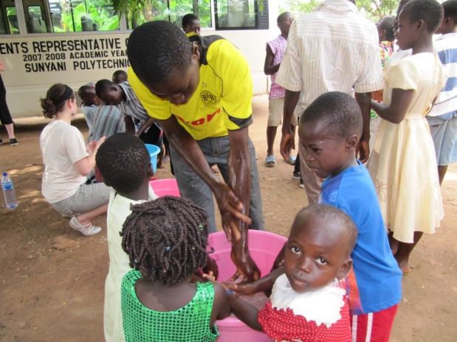
Hand Washing at Korkers

