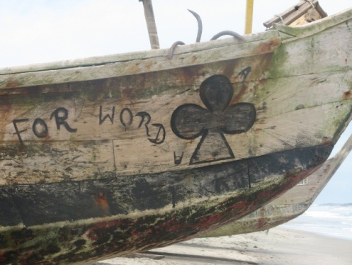
Closing Thoughts:
Questions and Considerations for Moving Forward

As we reflect back on our three weeks in Ghana and the enriching possibilities for faculty and students in the Faculty of Education, both excitement and caution come to mind. Having toured a number of diverse schools and educational sites throughout Ghana and engaged in collaborative discussions with potential Ghanaian partners, it might appear that we would have a confirming sense of the way forward after our time well spent in Ghana. And with previous cultural experiences for study, travel, and/or work in a wide range of countries and villages on the African continent and beyond, one might assume that we would have a strong sense of our role and purpose for building field schools, practicum & professional development opportunities, and partnerships in Ghana. Within this vast realm of educational possibility however, we find ourselves proceeding with eager anticipation mixed with feelings of uncertainty and careful consideration. Leaving Ghana with more questions than answers, increased understanding of the complexity of such cultural endeavours, and the slippery slope values and paradox found within the realm of ‘international development’, we recommend that a concerted amount of time be spent grappling with the following thoughts and considerations in collaboration with VIU colleagues and potential Ghanaian partners before we proceed with any great vigour.

[We need] a new international consciousness that recognizes and assures every community, language, culture, and civilization a future, with each culture and civilization open to learning from others. (Wangoola, 2006)

Of critical importance is making sure that we do not come across as the “Oh, we in the western countries are all helping you poor folk over there”, because we have some silent values around material acquisition and industrial development and when we see the absence of it we say, “Oh, you poor people” as if somehow there is something lacking, when we may not be recognizing our vantage point with which we view the world and our disconnect with a sense of global interdependence and interconnectedness. It is our belief that if we were to pursue a Ghanaian cultural exchange with the “poor them” syndrome, all we would be doing is a very good job of emulating our ethnocentric ways of being - and that may create a harmful disservice to all those involved in the process. To avoid this slippery slope we recommend that the first thing we need to do is recognize what our vantage point is or what our perspective is; then be open to the possibility of diverse perspectives and Ghanaian ways of knowing and being.

Today there is a worldwide concern with the condition of children: physical, material, spiritual, emotional. This is a new phenomenon. A generation or two ago, it was probably assumed that as children in the industrialized countries lived in earthly paradise, it was the condition of children in the majority (third) world which needed to be attended to. But the tendency among Afrikan elites has been to assume that the condition of children in the West sets the standards to be emulated. For many therefore, it comes as a shock that some of the indicators of a good life for children can be a danger to children’s welfare; for example, mountains of food, family cars, television, games and toys, and so forth. (Wangoola, 2006)
We wish to make no mistake in suggesting that the dire realities of hunger, poverty, and inequality that face millions of children in Ghana and worldwide are insignificant in our world today. Indeed, the alarming statistics are of utmost concern to all of us:

600 million children in the world live in absolute poverty, on less than one dollar a day. Ten million children die each year from preventable diseases;
60 million girls and 40 million boys do not have access to basic schooling….it is estimated that from 50 to 60 million children, instead of being in a classroom, are forced to undertake intolerable forms of labor;
Millions of children have died as a result of armed conflict in the last decade alone, while countless millions more have been left physically and emotionally disabled by armed conflicts where children have been deliberate targets;
In sub-Saharan Africa, it is estimated that 13 million children have lost their mothers or both parents to AIDS.
(Machel, 2006, p.186)

In December 2004, UNICEF released a document entitled Childhood Under Threat, which states that the survival of more than half the world’s children, numbering more than a billion, is currently at risk. Twenty-nine thousand children - living primarily in marginalized countries - are dying every day - mostly of preventable diseases, and more than three million are ensnared in the sex trade. However, children in privileged nations - such as Canada - are also suffering! Record levels of mental illness, violence, and obesity provide ample testimony to our failure to meet their daily needs (Olfman, 2006).
This seems to be a juncture in the history of humanity when all children of the world are under threat. This means humanity is under threat, both in the Majority (Third) World, and in the minority (industrialized) countries. In other words, the majority of peoples of the world who eke out a living on their sweat and resources of ancestral lands, and a small minority of peoples in a handful of countries who fatten themselves on the toil of others, both face a bleak future due to the growing threats posed to their children. (Wangoola, 2006, p. 119)
An important point that this report raises is that despite, or in the midst of, these dire struggles, men, women, and children from economically impoverished nations such as Ghana, are sharing signs of hope, resilience, resourcefulness, and community connectedness, and in some cases, even joy, through their every day representations of the world in which they live. With this in mind we suggest that we pursue our endeavours in Ghana with a desire to listen to, and to learn from, the people of Ghana while bracketing out our own prior assumptions and beliefs regarding progress, wealth, and development.
I Am Confident
It will be so exciting to be exposed to the world.
My heart will be rejoicing.
Oh, what a confidence in me…
I must dream of things that make me successful…
I have confidence in me.
Let them see who I am...

By: Zimasa Mgengo
Fezeke Secondary School
Guguletu, South Africa

In regards to our role as teachers and educators, our public school system - specifically its hegemonic influences in Ghana and worldwide - should be held partially responsible for the devastating state of humanity that confronts us in every corner of the world, including Ghana. Perhaps among the greatest gifts we, as educators from VIU can offer our partners in education within Ghana is a willingness to admit that we have made a colonial mistake in the way we have shaped their education and then strive to make it more relevant and purposeful for the Ghanaian land and people; and in the process, better understand the need for change within our own public education system.

The world is in crisis, suffering from insane violence, degradation of nature, rampant greed and commercialization, and loss of meaning and community, but the consuming goal of our schools is to train young people to compete in the job market, reinforcing the domination of the global corporate economy, which fuels many of these problems. Moreover, modern schooling, like any transmission-oriented model, prevents young people from recognizing or addressing critical problems in the world around them. So long as they are made to merely memorize the so-called facts presented in authorized textbooks, students are isolated from the difficult choices they will need to make, and the complex issues they will need to understand, if they are ever to respond effectively to this suffering world. (Miller, 2006, pp. 64-65)

As Miller (2006) suggests, an education that is relevant to our time cannot simply aim for transmission, but must support cultural reconstruction or transformation. Consequently, if we don’t choose to involve young people (in both Ghana and Canada) in “reconstructing our societies, in building a culture of peace, justice, compassion, their future looks bleak indeed, no matter what marketable skill their school provides them” (Miller, p. 64).

With the above thoughts in mind, and the many considerations that have provoked discussion within this report, the following questions and considerations arise to help us unfold the nature of our educational partnerships and pursuits with Ghana:

Questions

- Where is the greatest fit for Ghana partnering within VIU’s Faculty of Education? (i.e. B.Ed practicum, Directed study in Social Studies, Social Justice, etc., Proposed Global Education Graduate Diploma, etc.)
- Is there a fit within the Centre for International Education, Global Studies, and/or Aboriginal/Indigenous Education?
- What is our role, intention, and purpose for pursuing educational partnerships with Ghana?
- Whose benefit frames our decisions and actions?
- What is our vantage point, worldview, or perspective that guides us? How can we learn to ‘bracket out’ these frames of reference in order to become open to, and guided by others?
- How does the ‘power of words’ influence and impact our perceptions, roles, and intentions in Ghana? (i.e. ‘international development’, ‘progress’, ‘rich and poor’, ‘third world’, ‘underdevelopment’, ‘globalization’, etc.)
- Is good intention enough? What else is needed to ensure that harm or disservice is avoided?
- What does a true collaborative partnership entail between Canada (VIU) and Ghana members?
- What drives our intention for ‘gift-giving’? How can we express mutual gratitude and appreciation for our time in Ghana without portraying ourselves as an endless ‘money-pit’?
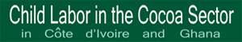
- How can we instil a sense of the bigger picture of interconnectedness in our decisions and actions? (i.e. bringing over ‘dollar store’ gifts to children in Ghana may promote sweatshop and child labour practices in other parts of the world; purchasing non-fair trade or organic chocolate in Canada may support child trafficking/labour and/or environmentally unsustainable practices on cocoa plantations in Ghana, etc.)
- How can we support a more relevant and purposeful education system in schools in Ghana and Canada? How can we promote curriculum that meet the needs and goals of a village or community rather than a standardized and globalized set of outcomes? How do standardized exams and tests influence the direction of education? What is needed to change this?
- In what ways can we assist in the facilitation of change within Ghana without taking on the role of change agents? How can we assist in the empowerment of the Ghanaian people to bring about the change they need or desire?
- How can hegemonic forces of the ‘west’ be avoided when considering change in Ghana?
- How might the Universal Declaration of Human Rights, the Rights of the Child, the Charter of Indigenous Peoples, and the Earth Charter fit into plans and conversations?

Considerations/Recommendations
- Establish extended time and focus at one or two schools (for practicum or field school experiences) – rather than many short stints - is recommended in order to build relationships and follow through at these sites. Suggested schools for upcoming year include Tema Ridge School (outside Accra) and Mole Primary School (within Mole National Park).
- Build ongoing written, creative, and oral reflection and debrief as an integral part of the process pre, during, and post work in Ghana in order to grapple with the many questions raised throughout this report.
- Establish partnerships with Ghanaian counterparts based on trust, reciprocity, and the gift of knowledge and relationships – without a focus on material gift-giving as the nature of our role and intent.
- Identify Global Arts exchanges within Canadian schools for Ghana’s Tema Ridge School and Mole Primary School. Suggestions include Queen Margaret’s School, Duncan & various teacher training practicum schools.
- Continue pursuing VIU interdisciplinary opportunities (i.e. Nursing, Tourism, Education, etc.).
- Continue embracing Cape Coast as a final debrief destination. Touring and debriefing the Castle that depicts the history of black slavery is also a valuable – albeit heartbreaking – site for understanding past and present Ghana
- Consider partnerships with Ghanaian student teachers for potential field school or practicum experiences and/or informal dialogue around the nature of education in Ghana and Canada. Recommended site is Berekum College of Teachers.
- Pursue research opportunities regarding transformational effects of cultural exchange opportunities (i.e. Ghana/Canada).
- Pursue research opportunities regarding the interconnectedness of Canadian consumer products & Ghana/worldwide resources & the social & environmental impacts (i.e. Nestle chocolate bars (cocoa), Shea Butter, Coffee, etc.).
- Investigate the power of story in understanding
In closing, perhaps the greatest outcome we can hope to achieve for students and faculty at VIU lies within the realm of relationship building and personal transformation - a profound shift of consciousness through experiences and encounters that touch us deeply and permanently shift the way we think, feel, and act in the world:
Such a shift involves our understanding of ourselves and our self-location; our relationships with other humans and with the natural world; our understanding of relations of power in interlocking structures of class, race, and gender; our body-awareness; our visions of alternative approaches to living; and our sense of possibilities for social justice and peace and joy. (Morrell & O’Connor, 2002)
Transformative learning in this context refers to the process by which we transform our taken-for-granted frames of reference to make them more inclusive, discriminating, open, emotionally capable of change, and reflective so that they may generate values and opinions that prove more true or justified to guide action (Mezirow, 2000).

With great enthusiasm and cautious decision-making we look forward to working with VIU and Ghanaian partners in the pursuit of cultural and environmental awareness, understanding, and action. Guided by our head, heart, and hands, may we pursue our actions with mutual respect for one another and conscious consideration for the interconnectedness of our planet and all its inhabitants.

‘Madesi Pa’ (‘Thank you very much’ for sharing in this dialogue),

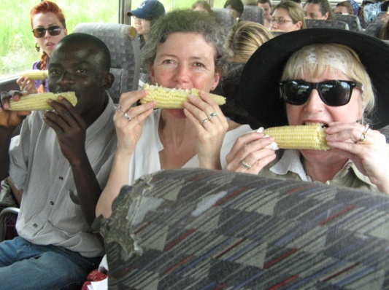
Mary and Nadine

The terms ‘marginalized’ and ‘privileged’ are utilized to counter the commonly misused labels such as ‘underdeveloped’-‘developed’; ‘poor’-‘rich’, ‘minority’-‘majority’, ‘third world’, etc. These terms suggest that ‘marginalized’ countries (i.e. India, Ghana, etc.), may be underrepresented or misunderstood, while ‘privileged’ nations (i.e. North America), are seemingly better off, but also misrepresented.

